Sue Armchair
Material: | Polypropylene
Colour: | 
Glides: | Plastic
Quantity: | 50
Guide Price:  (Per Item) | £81.74 Ex. VAT
Lead Time: | 5 - 7 weeks.

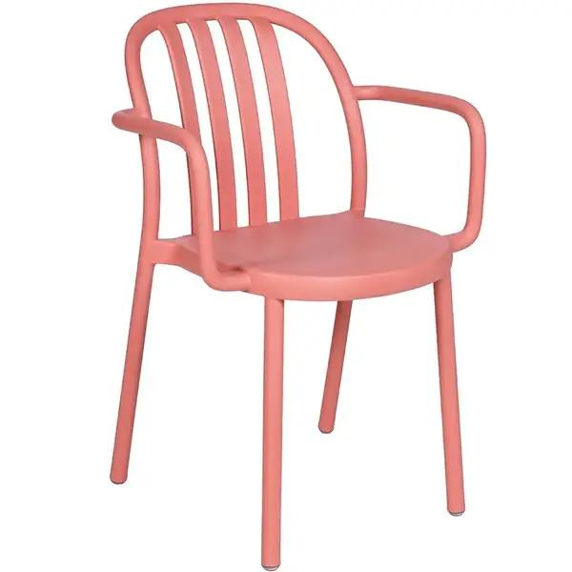

DIMENSIONS
Width: | 545 mm | Depth: | 530 mm
Height: | 800 mm | Seat Height: | 455 mm
Footprint: | 0.29 m² | Shipping Volume: | 0.430 m³
Fabric Requirement: | 0.000 lm | Leather Requirement: | 0.000 m²
Stack Height: | x7
DESCRIPTION

MORE IMAGES
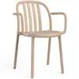 | 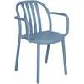 | 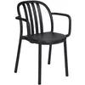 | 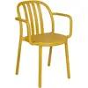 | 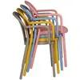 | 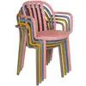
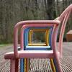 | 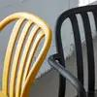 | 

